Exercises for Senior II Practice 6
Class _________ Name __________

I. Listening Comprehension
Section A 10%
1. A. Mother and child. B. Teacher and student.
C. Husband and wife. D. Boss and secretary.
2. A. They like reading today’s paper.
B. They are interested in today’s paper.
C. They found nothing interesting in today’s paper.
D. They have no idea what the paper is about.
3. A. In the concert. B. In the theatre. C. In the exhibition. D. In the studio.
4. A. Getting ready to board a plane.
B. Queuing up for the check-in.
C. Meeting friends at the arrivals.
D. Waiting at the baggage claim area.
5. A. The man doesn’t care which colour is chosen.
B. The woman prefers the colour.
C. The man is concerned about the colour.
D. The man intends to choose a different colour.
6. A. Doing a lot of homework. B. Staying focused in class.
C. Sleeping for a short break. D. Devoting all her spare time to learning.
7. A. He was chairman of the club.
B. He wanted to learn a new language.
C. He wanted to know more about the club.
D. He was interested in international advertisement.
8. A. The man should work hard. B. The man should turn down the job offer.
C. The man may have another chance. D. The man can apply for the job again.
9. A. Its ending is not good enough. B. Its structure is not satisfying.
C. It deserves an award. D. It is good except for the writing skills.
10. A. She likes watching instead of playing. B. She is a good team sports player.
C. She doesn’t like any kind of sports. D. She likes taking part in team sports.

Section B 15%
Questions 11 through 13 are based on the following passage.
11. A. It contains protein. B. It contains water.
C. It helps the brain work properly. D. A full stomach leads to a good sleep.
12. A. Sleep helps the brain control the senses.
B. Sleep promotes rest.
C. Sleep helps the brain revise and store information.
D. Sleep reduces tiredness.
13. A. Factors related to memory development. B. The importance of a good memory.
C. The importance of improving memory. D. The misery caused by a poor memory.
Questions 14 through 16 are based on the following weather forecast.
14. A. Mountainous Area. B. Northern Europe.
C. Eastern Europe. D. Southern Europe.
15. A. Snowy. B. Cloudy.
C. Rainy. D. Fine.
16. A. Northern parts of the Mediterranean.
B. Eastern parts of the Mediterranean.
C. Central parts of the Mediterranean.
D. Southern parts of the Mediterranean.

Questions 17 through 20 are based on the following conversation.
17. A. A university tutor. B. An insurance adviser.
C. An overseas study officer. D. A visa officer.
18. A. It is purchased in the country you will travel.
B. It provides just a few kinds of medical services.
C. It provides doctors who may speak your native language.
D. It offers sufficient cash to pay the entire bill on the spot.
19. A. It must be purchased in one’s home country before going abroad.
B. It does not cover the minor medical expenses.
C. It only recommends native doctors when you are aboard.
D. It features personal paying first and getting money later.
20. A. Consult other insurance companies.
B. Buy the student health insurance.
C. Get the international travel insurance.
D. Choose neither insurance since it is not a must.

II. Grammar and vocabulary
Section A 10%
Recreational Vehicles (房车): On the Road
Recreational vehicles (RVs) are a typically American invention. Nationally, sales rose to 430,000 units last year, a 40-year high. At the inexpensive end, they sell for as little as $5,000 for a caravan (大篷车); deluxe versions cost up to $1,000,000 and are typically equipped with a bedroom, kitchen and bathroom that are bigger than ones in many European flats. The share prices of Thor Industries, the biggest RV-manufacturer in America, and Winnebago, the third-largest, (21) _____ (rise) by 43% and 17%, respectively so far.
That is a big change. During the 2008-09 recession, notes Mr. Troiano, the owner of Continental RV, RV dealerships everywhere closed down, leaving his shop among the very few (22) ______ (leave) serving the New York metropolitan area. Mr. Troiano is on track (23) ______ (sell) more RVs this year than in any other since the early 2000s. The current rebound (反弹) is mostly (24) ______ ______ the economy’s recovery, but it also springs from the fact that new types of customer are embracing the lifestyle.
A decade ago, the average age of an RV-owner was 49, and over 90% were white, says Kevin Broom of the Recreational Vehicle Industry Association (RVIA), which doesn’t indicate a bright future. Another boost comes from sufficient immigrants, (25) ______ are keen to experience long, self-planned road trips in America. Mr. Troiano’s most recent big sale was to (26) ______ rich Asian family.
The industry hopes that its poor record with foreign sales — last year less than 1% of RVs produced domestically (27) ______ (ship) to foreign markets — may improve, too. China’s government, for example, has planned to build 2,000 campgrounds by 2020, up from an estimated 300 today, in a bid to promote domestic tourism, particularly to remote rural regions. Chinese firms such as Yutong Bus make RVs, but not of the quality that many Chinese want. The country imported 1,000 vehicles last year, over half of them American.
RV manufacturers are also marketing the concept (28) ______ their motor homes can be commercial as well as leisure vehicles. They (29) ______ allow travelling salesmen, businessmen to save on food and hotel costs. (30) ______ you park it, it can be your office, as well as your home.

Section B 10%
Directions: Fill in each blank with a proper word chosen from the box. Each word can be used only once. Note that there is one word more than you need.
A. accompanied B. commercially C. computerized D. contents E. decline F. distinguish G. funded H. measures I. potentially J. processing K. respond
Training the Brain to Hear Better
The din （喧嚣）of a loud restaurant or party can make conversation difficult for anyone — but for the elderly, these settings can make it nearly impossible. The mechanics of hearing ____31____ with age, but the latest research focuses on another part of the problem — the slower ____32____ speed of aging brains, which have to work harder to translate sound into intelligible (可理解的) language.
Research shows that musicians are better able to pick out speech from surrounding noise as they age compared to non-musicians．And a new study of auditory training with a ____33____ available brain training program suggests that most people who are hard of hearing can develop the same skills．The scientists showed that people trained for 40 hours over 8 weeks with Posit Science’s “Brain Fitness” were able to pick out 41% more words from background noise compared to those who watched educational DVDs and were quizzed on their ____34____ after the same amount of time．The authors received no funding from the makers of the program; the study was ____35____ by the National Institutes of Health.
The research included 67 older adults between 55 and 70, with an average age of 63．The auditory training came in the form of ____36____ hearing tasks that primed the participants to hear better by requiring them to identify various speech sounds and ____37____ between similar sounding syllables (音节), for example, as well as repeating back words and remembering stories．
Both those who received the training and those who watched the DVDs were tested on short term memory, brain processing speed and the ability to hear speech in noisy settings．All of the participants showed improvement in these three ____38____, but for the first time, the scientists also documented that the sharper hearing was ____39____ by earlier signaling in the brainstem.
As the authors write in their paper, the training not only improved the ability to decode speech in noisy situations, but also sped up the brain’s ability to ____40____ to the sound — bringing it to more “youthful’’ levels．

III. Reading Comprehension
Section A 15%
Depression: Second Biggest Cause of Disability in the World
Depression is the second most common cause of disability worldwide after back pain, according to a review of research. The disease must be treated as a global public health __41__, experts report in the journal PLOS Medicine. The study __42__ clinical depression with more than 200 other diseases and injuries as a cause of disability. Globally, only a small proportion of patients have __43__ to treatment, the World Health Organization says.
Depression was __44__ at number two as a global cause of disability, but its impact varies in different countries and regions. __45__, rates of major depression were highest in Afghanistan and lowest in Japan. In the UK, depression was rated at number three __46__ years lived with a disability.
Dr. Alize Ferrari from the University of Queensland’s School of Population Health led the study. “Depression is a big problem and we __47__ need to pay more attention to it than we are now,” she told BBC News. There’s still more work to be done in arousing awareness of the disease and also in __48__ successful ways of treating it.
“The burden is different between countries, so it tends to be higher in low and middle income countries and __49__ in high income countries.” Policy-makers had made an effort to bring depression to the forefront, but there was a lot more work to be done, she added. “There’s lots of stigma (病症) we know __50__ with mental health,” she explained.
“What one person recognizes as disabling might be different to another person and might be different across countries as well. There are lots of cultural __51__ and interpretations that come in place, which makes it all the more important to __52__awareness of the size of the problem and also signs and how to __53__ it.”
The data — for the year 2010 — follows similar studies in 1990 and 2000 looking at the global burden of depression.
Commenting on the study, Dr. Daniel Chisholm, a health economist at the department for mental health and substance abuse at the World Health Organization said depression was a very disabling condition. “It’s a big public health __54__and a big problem to be reflected on but not enough is being done.” Around the world only a tiny __55__ of people get any sort of treatment or diagnosis.
The WHO recently launched a global mental health action plan to raise awareness among policy-makers.
41. A. concern B. issue C. priority D. discussion
42. A. compared B. combined C. confused D. contacted
43. A. objection B. access C. adaptation D. contribution
44. A. considered B. evaluated C. determined D. ranked
45. A. For example B. In addition C. In other words D. All in all
46. A. in regard of B. in name of C. in terms of D. in face of
47. A. probably B. definitely C. significantly D. randomly
48. A. coming up with B. making up C. putting up with D. consisting of
49. A. severer B. heavier C. lighter D. lower
50. A. related B. associated C. relevant D. close
51. A. ingredients B. interactions C. implications D. identities
52. A. remove B. recreate C. raise D. rise
53. A. avoid B. treat C. cure D. detect
54. A. challenge B. agreement C. prediction D. outcome
55. A. amount B. proportion C. quantity D. population

Section B 22%
(A)
Digital Etiquette (礼节)
Digital Etiquette, or netiquette, is a set of rules for how to behave online. It’s a lot like life etiquette, which is basically having good manners and treating others with respect. It’s just as important in our digital lives, including how we act in online games or how we communicate in emails, texts, instant messages and on social networking websites. All of these platforms let us talk and share instantly wherever we are.
Unfortunately, some people can lose control the second they jump online. When they disagree with someone, or have strong feeling about a topic, they end up saying stuff they’d never say in person! They may send ruder emails and IMs or try to start arguments on message boards. That’s called flaming, and it can lead to full-on flamewars, insulting arguments between two or more users.
On the Internet, it’s pretty easy to stay anonymous, or unidentified. Having a secret identity to hide behind can make people pretty brave. And when all they see of you is screen name or a funny icon, they might forget that they’re dealing with a real human being!
The principle is simple: Just like in real life, you should treat other people the way you want to be treated. You wouldn’t want somebody to be rude to you, so don’t be rude to anyone else.
Of course, netiquette isn’t just about being nice; it’s also about communicating clearly. That means keeping emails and IMs clear, and to the point. It also means making your messages easy to read and understand, which can depend on your audience. For instance, some abbreviations and emoticons may be fine with friends. But they’re generally not appropriate in formal communication. And whatever you do, don’t write in all capital letters! Writing in all caps makes it seem like you’re yelling.
Lastly, make sure you ask permission before posting anything about your friends on a blog or a social networking site. People’s personal information is private, and you can really ruin relationships if you post something that a friend — or a friend’s parents — don’t want on the web. And keep in mind that the Internet is not a private place; if you wouldn’t want a parent, teacher or future employer to see something you post, don’t post it!
56. According to the passage, the users of social media are advised ______.
A. to trigger arguments on message boards
B. to behave online with common courtesy
C. to be respectful of others online rather than offline
D. to apply abbreviations and emoticons as many as possible
57. Why might an anonymous Internet user feel bold enough to say horrible things in response to a blog post?
A. Because he can make more friends if he says mean things.
B. Because he knows his friends will recognize him and think better of him.
C. Because he can insult others and not worry about revenge.
D. Because he can impress older, smarter people with his remarks.
58. Which of the following is the best way to text your uncle to say you’ll be back in an hour?
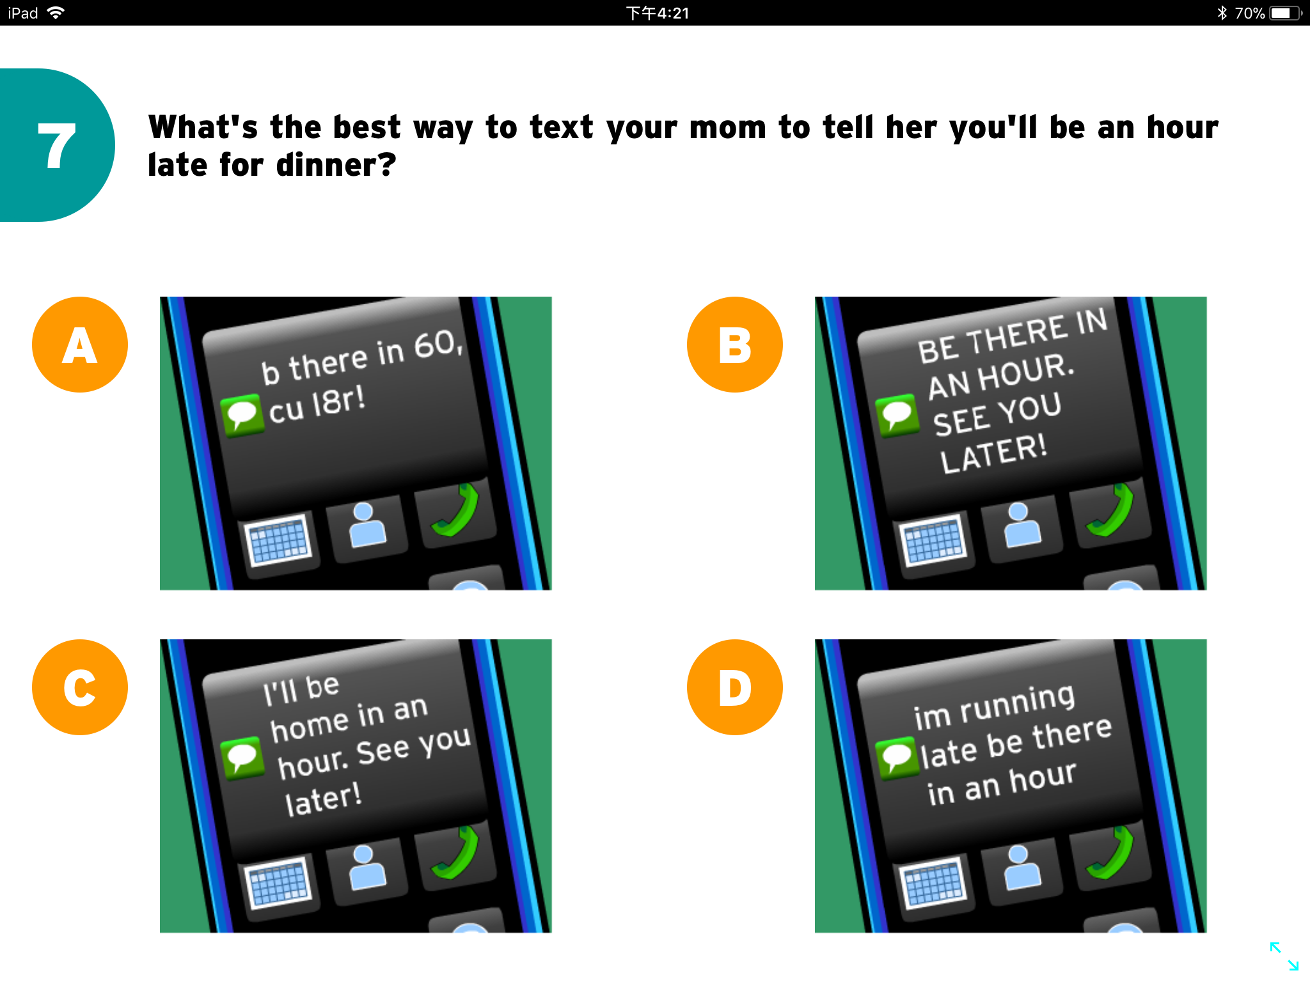
A. B.

C. D.

59. Which of the following is a clear rule about posting photos online?
A. If you take a photograph, it is yours to do as you please online.
B. Information about your friends, including photographs, is private.
C. It’s illegal to post pictures online without permission from people in the pictures.
D. You should always avoid posting images on the internet.

(B)
Recycling at work - handy hints to employers
It is estimated that avoidable waste costs UK businesses up to 4.5% of their annual revenue. Reducing waste in the workplace is about being efficient. By becoming more efficient, businesses not only increase profits but they also save natural resources.
Setting up a company scheme
Get everyone involved
• Arouse awareness internally within the company, perhaps by putting up educational posters.
• Appoint a person to be the point of contact for anyone with queries (问讯).
There are also a couple of ways to increase motivation:
- Hold internal competitions between different departments. For example, see which can reduce their waste the most within a specific time period.
- Send out regular newsletters reporting on all waste improvements. Staff will then see the impact their actions are having.
What to recycle and how
Paper
• According to a recent survey, 65% of waste produced is paper waste. Waste paper will inevitably be produced in the workplace, but it is not necessary to discard it. It can serve a variety of purposes before it is recycled, such as writing notes. Envelopes too can be reused for internal mail.
Plastic cups
• Rather than supplying disposable plastic cups in your workplace, get ceramic mugs that can be reused. Not only do they make your tea taste better, but they can reduce your office waste by up to 10%!
Electrical equipment
• Rather than giving up on any old electrical equipment and just throwing it away, why not try upgrading it? This reduces waste, as well as avoiding the need to manufacture a new machine - a process which creates a large amount of waste. You could also consider donating your old computers to charities when
it comes to replacing them.

Recycling at work - handy hints to employers

60. What can the employer distribute to motivate staff to recycle more?
A. Educational posters. B. Annual reports.
C. Regular newsletters. D. Competition rules.
61. What can be bought to cut down on the waste produced by staff refreshments?
A. Disposable goods. B. Writing notes.
C. Envelopes. D. Ceramic tableware.
62. Which of the following is NOT included in the hints?
A. Unwanted PCs can be sent to charities if the company has to buy new ones.
B. Waste paper can be used as envelopes for internal mails before being thrown away.
C. One of the staff should be assigned to be responsible for the recycling issue.
D. Educational posters can be displayed in the workplace to publicize the recycling scheme.

(C)
Given how valuable intelligence and automation are, we will continue to improve our technology if we are at all able to. At a certain point, we will build machines that are smarter than we are. Once we have machines that are smarter than we are, they will begin to improve themselves. And then we risk what the mathematician IJ Good called an “intelligence explosion”. The process could get out of control.
The concern is really that we will build machines that are much more competent than we are. And the slightest divergence between their goals and our own could destroy us. Just think about how we relate to ants. We don’t hate them. We don’t go out of our way to harm them. In fact, sometimes we take pains not to harm them. We step over them on the sidewalk. But whenever their presence seriously conflicts with one of our goals, we will kill them without hesitation. The concern is that we will one day build machines that, whether they’re conscious or not, could treat us with similar disregard.
The bare fact is that we will continue to improve our intelligent machines. We have problems that we desperately need to solve. So we will do this, if we can. The train is already out of the station, and there’s no brake to pull. If we build machines that are more intelligent than we are, they will very likely develop in ways that we can’t imagine, and exceed us in ways that we can’t imagine.
So imagine we hit upon a design of superintelligent AI that has no safety concerns. This machine would be the perfect labor-saving device. It can design the machine that can build the machine which can do any physical work, powered by sunlight, more or less for the cost of raw materials. So we’re talking about the end of human labour. We’re also talking about the end of most intellectual work. So what would apes like ourselves do in this circumstance?
What would some nations do if they heard that some company in Silicon Valley was about to deploy (配置) a superintelligent AI? This machine would be capable of starting war, whether terrestrial (陆地的) or cyber, with unbelievable power.
Given that the companies and governments building superintelligent AI are likely to perceive (感知) themselves as being in a race against all others, and that to win this race is to win the world, it seems likely that whatever is easier to do will get done first unless it is destroyed in the next moment.
But the moment we admit that information processing is the source of intelligence, we have to admit that we are in the process of building some sort of god. Now would be a good time to make sure it’s a god we can live with.
63. When an intelligent machine becomes smarter than humanity, ______.
A. it will make itself better and may go beyond human control
B. it will help people to the fullest, especially in physical work
C. it will threaten people by robbing them of jobs
D. it will view itself as human race
64. The underlined word “divergence” in Paragraph 2 almost means the same as “______”.
A. connection B. hatred C. competition D. disagreement
65. How is the passage mainly developed?
A. By making comparisons.
B. By showing valid evidence.
C. By giving assumptions.
D. By analyzing statistics.
66. Which of the following is the best title of the passage?
A. For the God’s sake, stop AI and be yourselves!
B. Can we build AI without losing control over it?
C. For or against AI, that is the question!
D. How does superintelligence serve the people?

Section C 8%
Directions: Read the passage carefully. Fill in each blank with a proper sentence given in the box. Each sentence can be used only once. Note that there are two more sentences than you need.
A. Parents simply cannot control all the possible paths their children may take.
B. Research in developmental psychology ought to help parents relax.
C. If a woman works outside the home, she’s depriving her children of her constant attention, but if she stays home, she tends to give her children too much love.
D. According to Freud, after the first five “formative years” ended in the crisis of the Oedipal Complex (俄狄浦斯情结), the child’s personality was set for life.
E. Parents still have a major role to play, but now it is more delicate.
F. Obviously it’s good to give children stimulation and attention from the start, but one wrong step will not doom the child to psychological damage.

Parenting Anxiety Relieved
Women are insecure because there is no commonly accepted idea of what it means to be a good mother. Fathers have it easier in this regard; they just have to show up and they are automatically considered “good”, whereas mothers are always trying to prove to themselves and the world that they aren’t “bad”. _______67_______
In some ways, things are getting worse. Years ago, a woman was allowed five years to shape her child’s personality. In recent years, however, some psychologists tell mothers that the first three years of life are the most important, while others think that all critical events happen during the first year.
Ironically, this panic about doing the right thing to produce the perfect child is probably the worst thing for the child and the parent. _______68_______ Here is why.
First, it is not harmful to children if their mothers work. Mothers who neglect their own need and abilities for the sake of their children do not benefit their children, their marriage or themselves.
Second, there is no crucial moment or stage in early childhood in which a child’s fate is determined forever. _______69_______ Children are more flexible than that.
Research also finds that some children who have had the best parental care and guidance later give in to drugs, addiction, mental illness or violence. _______70_______ Between the parents’ best efforts and the resulting child lie other factors: the child’s nature, genetically influenced characters, experiences outside the family and the child’s knowledge of events. Parents can help an inborn shy child learn to cope better in situations that make the child anxious, but they aren’t going to turn her into Britney Spears.

V. Translation 15%
Directions: Translate the following sentences into English, using the words given in the brackets.
72. 众所周知, 与他人和睦相处是生活幸福的要素之一。（As）

73. 你认为以健康为代价来获取名利值得吗? （worthwhile）

74. 学生们接触到金融问题的年龄越小，就越有可能成为能有效地管理资产且有责任心的成年人。（expose）

75. 各行各业的人民群众对“不忘初心，牢记使命。”这句话都有自己深刻的理解。(saying)

